Objective:
Program 1: Basic Text Display

To print the name and subject information on the screen using printf() function.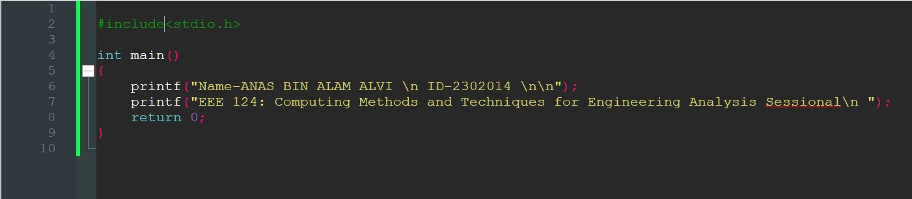
Program:

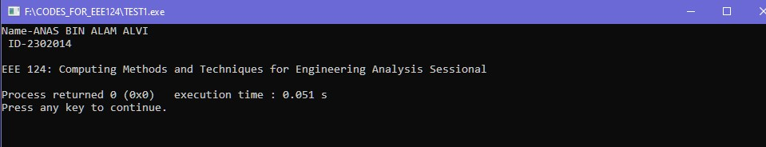
Output:
Start
Display : Name and ID
“EEE 124: Computing Methods and Techniques for Engineering Analysis Sessional”
Stop
Flow chart:

Discussion:
- Uses basic printf() for output.
- Demonstrates **string printing** in C without requiring input.
- Helps in understanding the fundamental syntax of C.

Conclusion:
This program is useful for displaying static information and serves as an introduction to basic output formatting in C

Objective:
Program 2: Addition of Two Numbers
To take two numbers as user input and calculate their sum.
Program
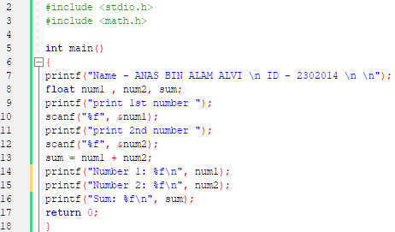
:
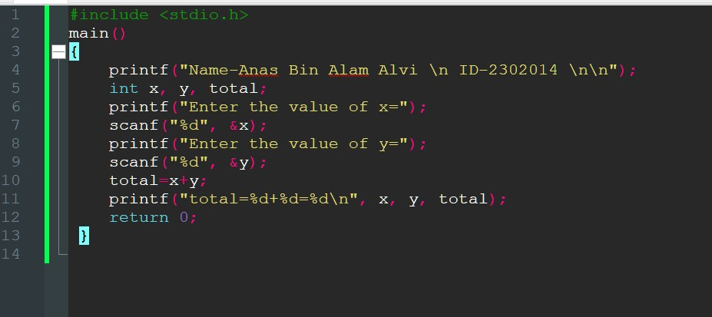

Output:
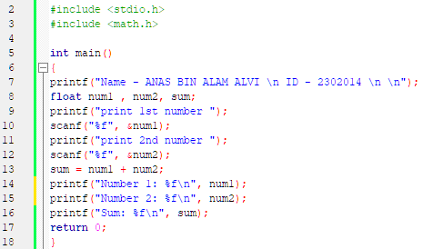

Output:

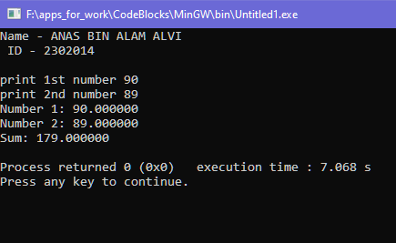

Stop
Start
Display total
Int total=x+y
Display : Name and ID int x = 90
int y = 89
Flow chart:
Discussion:
Stop
  - Uses scanf() to take user input.
  - Performs addition using the ‘+’ operator.
  - Demonstrates user interaction with the program.

Conclusion:
A basic interactive program that allows users to input two numbers and calculates the sum dynamically.

Objective:
Program 3: Multiplication of Two Numbers

To take two numbers as user input and calculate their product.
Program:
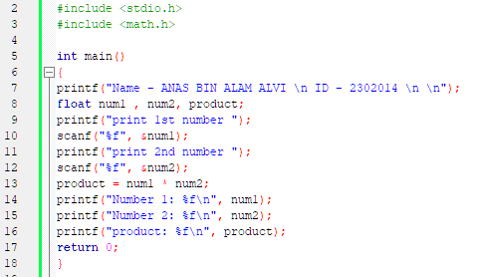

Output:
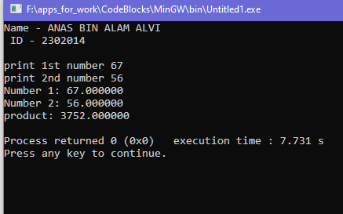

Flow chart:

Start
Display : Name and ID int x = 67
int y = 56

int product = x*y

Display product
Stop

Discussion:
  - Uses scanf() to take user input.
  - Performs multiplication using the ‘*’ operator.
  - Demonstrates user interaction with the program.
Conclusion:
This program reinforces user input handling and mathematical operations, demonstrating **multiplication functionality** in C.

Objective:
Program 4: Area of a Circle

A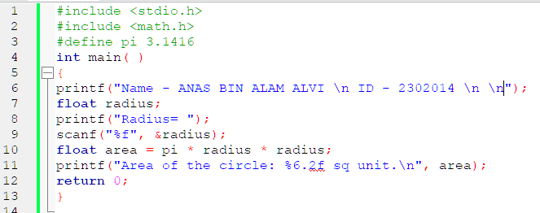
Program:

Output:
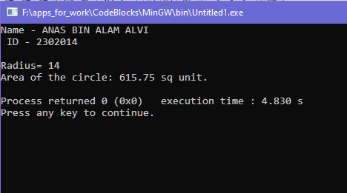

Flow chart:
Start

define PI = 3.1416
Display : Name and ID int radius = 14

float area = PI * r * r

Display area
Stop

Discussion:
  - Uses #define to define universal constants.
  - Handles floating-point arithmetic.
Conclusion:
This program demonstrates **mathematical calculations** in C and highlights how external libraries (math.h) can be used.

Objective:
Textbook 1.9 : Temperature Conversion
(Celsius to Fahrenheit & Vice-Versa)

To convert temperatures between Celsius and Fahrenheit using standard formulas.
Program:
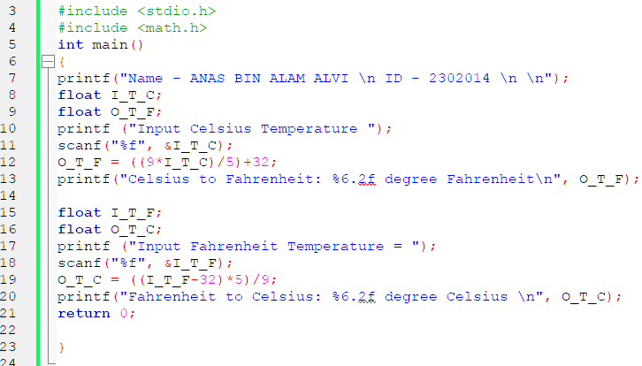
Output:
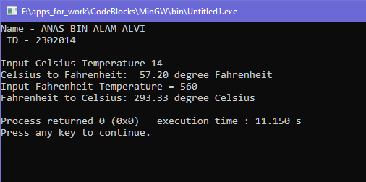

Flow chart:
Start
Display : Name and ID float I_T_C = 14
float I_T_F = 560
float O_T_F = (9*I_T_C/5) + 32
float O_T_C = (I_T_F - 32)*5/9
Display temperature
Stop

Discussion:
  - Uses conversion formulas:
- F = (9/5 × C) + 32
- C = (F - 32) × 5/9
  - Implements floating-point calculations** (%f) for scanf().
Conclusion:
This program reinforces user input handling and mathematical operations, demonstrating **multiplication functionality** in C.

Objective:
Textbook 1.10 : Area of a Triangle
To compute the area of a triangle given three sides
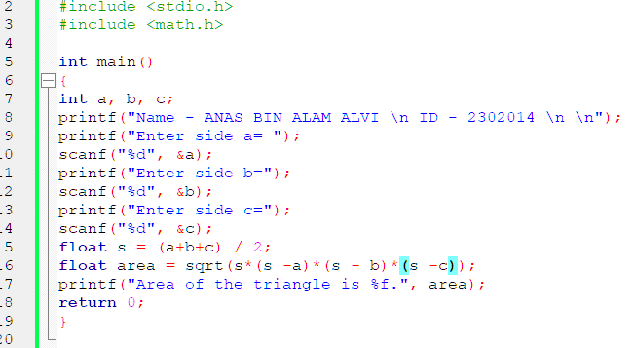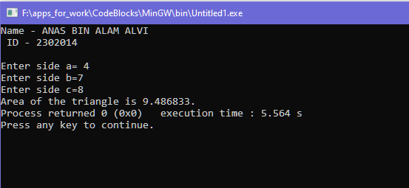
Output:
Program:

Display : Name and ID int a = 4
int b =7
int c = 8
Start
Flow chart:
Display area
Stop

float area = sqrt(s(s-a)(s-b)(s-c))

Discussion:
  - Uses math.h for sqrt() function.
  - Implements semi-perimeter (s) calculation.
  - Handles floating-point arithmetic.
Conclusion:
This program demonstrates **mathematical calculations** in C and highlights how external libraries (math.h) can be used.
To calculate the distance between two points (x1, y1) and (x2, y2) using the distance formula.
Objective:
Textbook 1.11 : Distance Between Two Points
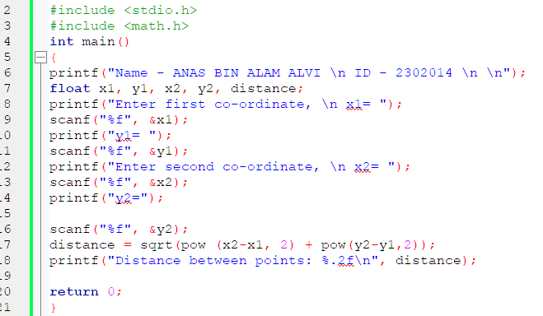
Program:

Output:

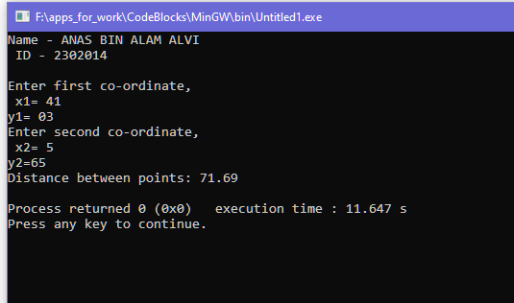
Flow chart:
Start
Display : Name and ID int x1 = 41
int y1 = 3 int x2 = 5 int y2 = 65
float distance = sqrt (pow(x2-x1,2 ) + pow(y2 -y1, 2))

Display distance
Stop

Discussion:
- Uses coordinate geometry principles for calculating distance.
- Implements the sqrt() and pow() functions from (math.h).
- Ensures correct user input handling using scanf() for real-time calculations.
- This concept is widely used in graphics programming, physics, and navigation systems.

Conclusion:
This program correctly computes the Euclidean distance, enhancing spatial calculations that are crucial in engineering and real-world applications.
Objective:
Textbook 1.12 : Circle Perimeter & Area Calculation

To calculate the radius, perimeter, and area of a circle centered at (0, 0) given a point (4,5) on its circumference.
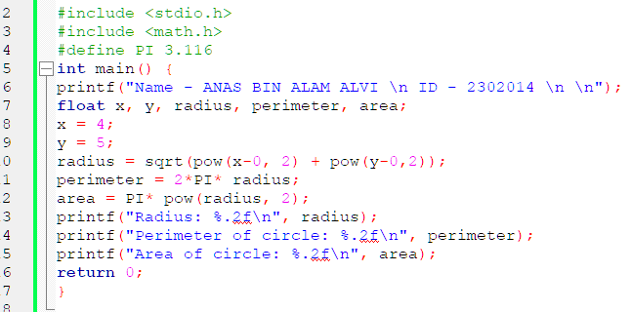
Program:

Output:
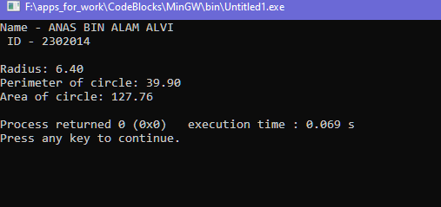
Flow chart:
Start

Stop
Display- radius, perimeter and area
float radius =sqrt (pow(x-0,2 ) + pow(y-0, 2)) float perimeter = 2*PI*radius
float area = pi* radius*radius
Display : Name and ID int x = 4
int y =5
define PI 3.1416

Discussion:
- Uses distance formula to determine the radius (r).
- Implements circle formulas:
perimeter= 2*PI*radius
area=PI*radius*radius
- Demonstrates constant value usage (PI = 3.1416) for precision.
- Essential for geometry-based calculations, graphical modeling, and physics applications.
Conclusion:
This program effectively determines key circle properties, showcasing how mathematical formulas can be applied dynamically in computational geometry.

Objective:
Textbook 1.13 : Circle Area Using Diameter

To compute the diameter, radius, and area of a circle using two given points on its circumference.
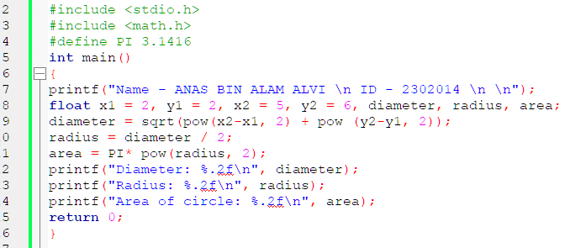
Program:

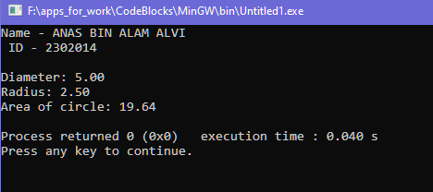
Output:

Flow chart:
Start
define PI 3.1416
Display : Name and ID
float x1=2, y1=2 ,
x2=5, y2=6
Display diameter radius area
Stop
float diameter = sqrt (pow(x2-x1,2 ) + pow(y2-y1, 2)) float radius = diameter / 2
float area = PI*radius*radius

Discussion:
Utilizes the distance formula to determine the circle’s diameter.
Derives radius from diameter using r=D/2.
Implements area formula A=πr² for precise computation.
Relevant in computer graphics, engineering simulations, and physics modeling.
Conclusion:
This program demonstrates how diameter leads to precise area calculation, reinforcing coordinate geometry and formula application in real-world problem solving.

